**PROJECT REPORT TEMPLATE**

**THE GLOBAL AIR TRANSPORTATION WITH NETWORK**

**INTRODUCTION**

The air transport network is one of a country's essential infrastructure assets. It is a vital component for economic development and growth. It provides the only global transportation network for people and goods. Air transport creates significant value for its users and for other stakeholders in the wider aviation industry - including governments. ‘ But the air transport network also generates wider economic benefits by allowing firms to be more efficient and productive and by encouraging higher investment. Within the air transport network, each origin airport is connected to a vast number of different destinations via flights to and from 'hub' airports.

Businesses - and the wider economy - benefit from the ability to access both a greater number of destinations and a higher frequency of services than would be possible through disjointed point-to-point services. In other words, businesses benefit both from more frequent services to major destinations and from the ability to access additional economically important destinations through onward flights. All airlines that provide services between airports within the network contribute to its wider economic value.

**Purpose**

The air transport network is a key infrastructure asset. It is the only worldwide passenger and cargo transportation network, providing an essential link between individual countries and the wider global economy. Air services create significant value for passenger and freight

PROBLEM DEFINITION AND THINKING

**EMPATHY MAPPING**

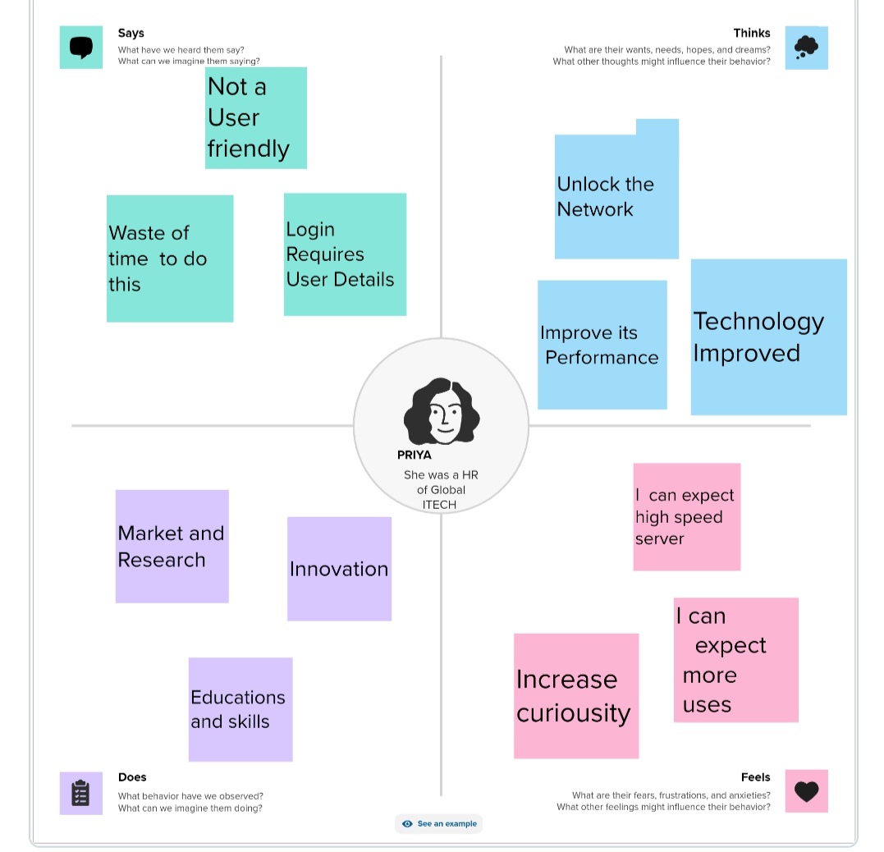

**BRAINSTORMING**

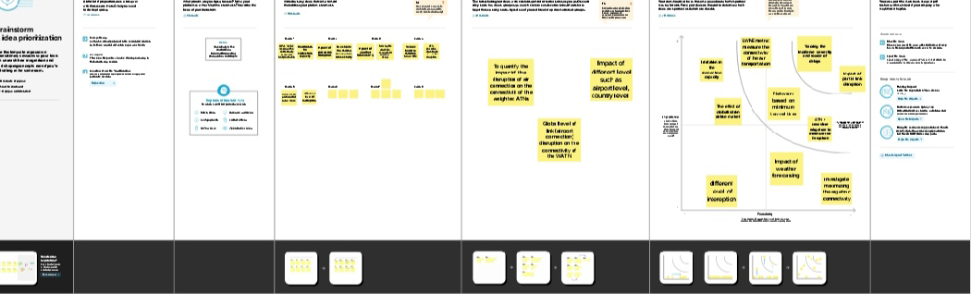

**KEY RESULTS**

The air transport network plays a key role in supporting and facilitating economic growth. The benefits it creates

Accrue not just to the users of air services but also to the wider economy. Developing economies, in particular, benefit from increased access to the global air transport network, allowing their firms to reach new markets and access new sources of investment and technical knowledge.

The survey and statistical evidence demonstrates that:

* The air transport network opens up new sales markets and boosts production efficiency and investment
* The Air Transport network will become even more important to firms over the next ten years
* Businesses attach a significant value to the scope and convenience of the air transport network

**Advantages of Air Transport**

1. **High Speed**

Air is the type of freight capable of traveling long distances in short periods of time. This makes this model an optimum choice if the client has an urgent need to ship a product or if their freight demands special standards of protection or acclimation.

1. **Fast Service**

Air transportation offers convenient, reliable and fast services of transport. It is considered the cheapest way to ship peregrinated goods. It offers a standard, convenient, reliable and fast service.

1. **Send almost everywhere your freight**

In regions that are not readily accessible to other modes of transport, air transport is considered to be the only means of transport. Open to all regions, irrespective of land interference. A vast network of airlines covering nearly the whole globe is available for many airlines. This ensures that the package can be sent almost anywhere.

1. **High Standard of Security**

High standard of protection with a low risk of robbery and injury. Shipping by air has a high degree of security since airport safety restrictions on cargo are strictly enforced. Tightly controlled airport controls also minimise cargo theft and loss.

**Disadvantages of Air Transport**

1**. Risky**

Air travel is the riskiest mode of transport, since there can be considerable losses to goods, customer and crews as a result of a minor crash. Compared to other means of travel, the risks of collisions are higher.

2. **Cost**

Air travel is considered to be the most expensive means of transportation. The cost of maintaining aircraft is higher and the costs for the building of aerodromes and avions are much higher. That’s why air travel is so expensive that it gets beyond ordinary people’s grasp.

3. **Some Product Limitation**

There is a whole variety of materials not suitable for such products, from explosives, gases, batteries, fired solids and liquids, which cannot be shipped by air to name but a few.

4. **Capacity for Small Carriage**

The aircraft have no room and therefore are not ideal for carriage of voluminous and cheaper materials. As is seen for rails, the load volume cannot be raised.

**Application Of Global Air Transport**

Modeling air transport networks aims airline companies to organize their routes in a cost-efficient way and therefore maximize their profits. Air transport network models are also the tool to investigate system robustness. They help to determine weaknesses of the system in case of various kinds of disruptions. The survey of businesses provides significant supporting evidence for the wider economic benefits (or positive externalities) that are generated by the air transport network. These benefits accrue not just to the users of air services but to national economies too. Air transport plays a key role in supporting and generating sales, by providing access to wider customer markets than would otherwise be possible. But air transport also has a significant impact on the efficiency of production. It allows firms to exploit economies of scale, operate efficient production techniques, sources are Cost-effective inputs and transfer and absorb knowledge from overseas.

The survey demonstrates the value that the air transport network itself provides, through its higher frequency and its ability to serve a greater number of destinations than would be possible otherwise. The value of this network will increase even further over the next ten years, even with the widespread adoption of new communications technologies.

**CONCLUSION**

The connectivity measure that is used will pick-up both the quantitative and qualitative impacts of air travel. For example, as air transport usage increases in a country, so the number of air services will increase and, therefore, connections to other destinations will increase as well as the frequency with which they are served. However, by using a connectivity measure this analysis highlights that there is a quality impact associated with the network, over and above the impact of just increasing air transport usage. It provides further support, in addition to the survey evidence of the previous chapter, on the wider economic value of the air transport network

**FUTURE SCOPE**

The most recent estimates suggest that demand for air transport will increase by an average of 4.3% per annum over the next 20 years. If this growth path is achieved by 2036 the air transport industry will then contribute 15.5 million in direct jobs and $1.5 trillion of GDP to the world economy.

**SOURCE CODE**

https://public.tableau.com/app/profile/k.atchaya/viz/DATASETKKK/Story1?publish=yes